Introduction 1

Why I chose mobile games for my assignment 1

Why mobile games matter 2

How JavaScript Helps in Mobile Game Development 2

FrameWork and Designs 2

Header 4

History and Today 5

Text and Colour 6

Speech Bubble 6

First Five Games 7

Snake Game 9

# Introduction

## Why I chose mobile games for my assignment

I chose to focus on the history of mobile games for my JavaScript project because of my passion for both gaming and web development. JavaScript is often used to create games, making it a great choice for exploring this topic. Mobile games have been a significant part of our lives, with classic games like Snake and Tetris still being some of the most well-known and beloved games today. The challenge of recreating a game like Snake using JavaScript was a fun and exciting task that allowed me to blend my interests in gaming and coding.

## Why mobile games matter

Mobile games are an important part of many people's lives. They provide entertainment and help us relax. Games like Snake and Tetris were some of the first mobile games and they showed how simple games could be really engaging. Today, mobile games have become much more advanced, with better graphics and more complex gameplay, but the basic idea of having fun with simple mechanics remains the same. Some of the simplest games remain the most popular like Snake, Tetris and even Minecraft used JavaScript.

## How JavaScript Helps in Mobile Game Development

JavaScript is crucial in mobile game development. It allows developers to create games that work on iOS, Android, and Windows platforms from a single codebase, ensuring broad reach.

JavaScript supports both frontend and backend development. It enables the creation of interactive game interfaces with HTML and CSS, while also handling server-side logic and real-time data processing for features like multiplayer games and leaderboards.

The extensive community support and resources available for JavaScript also make it easier to learn, troubleshoot, and stay updated with the latest advancements.

# FrameWork and Designs

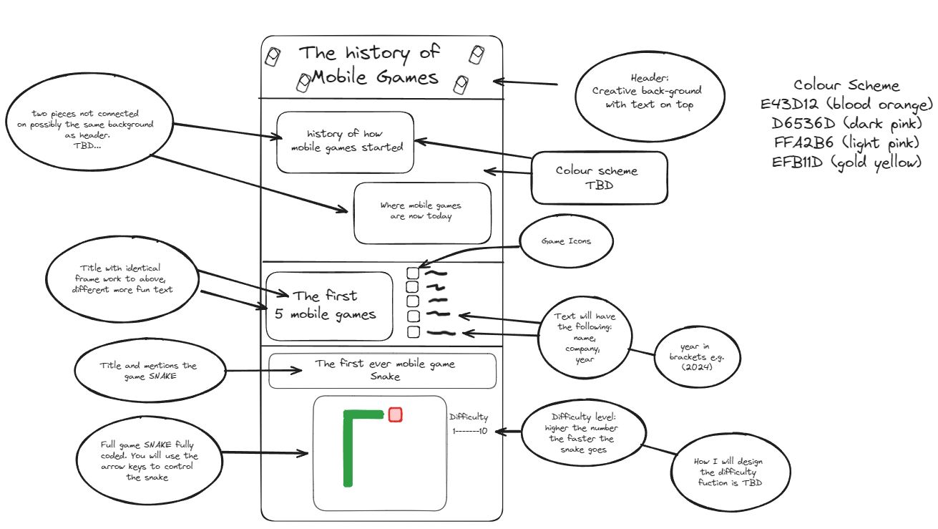

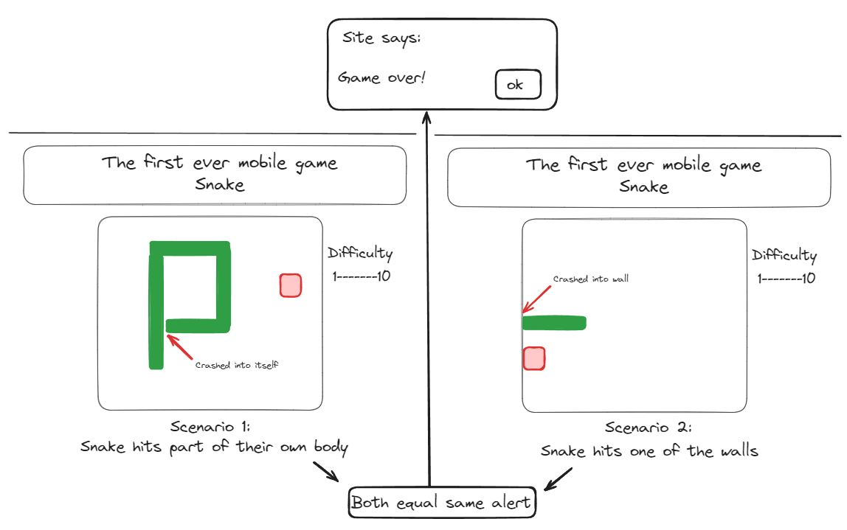These were all made on https://excalidraw.com/

These were my first designs, and it became a great starting point when creating my website. The final submission of the website was slightly different, but it kept most of the layout the same.

I also wanted a colourful colour-scheme for my website, so I checked Visme [(Chibana, no date)](https://sciwheel.com/work/citation?ids=16581920&pre=&suf=&sa=0&dbf=0) which showed me this colour scheme for a website.

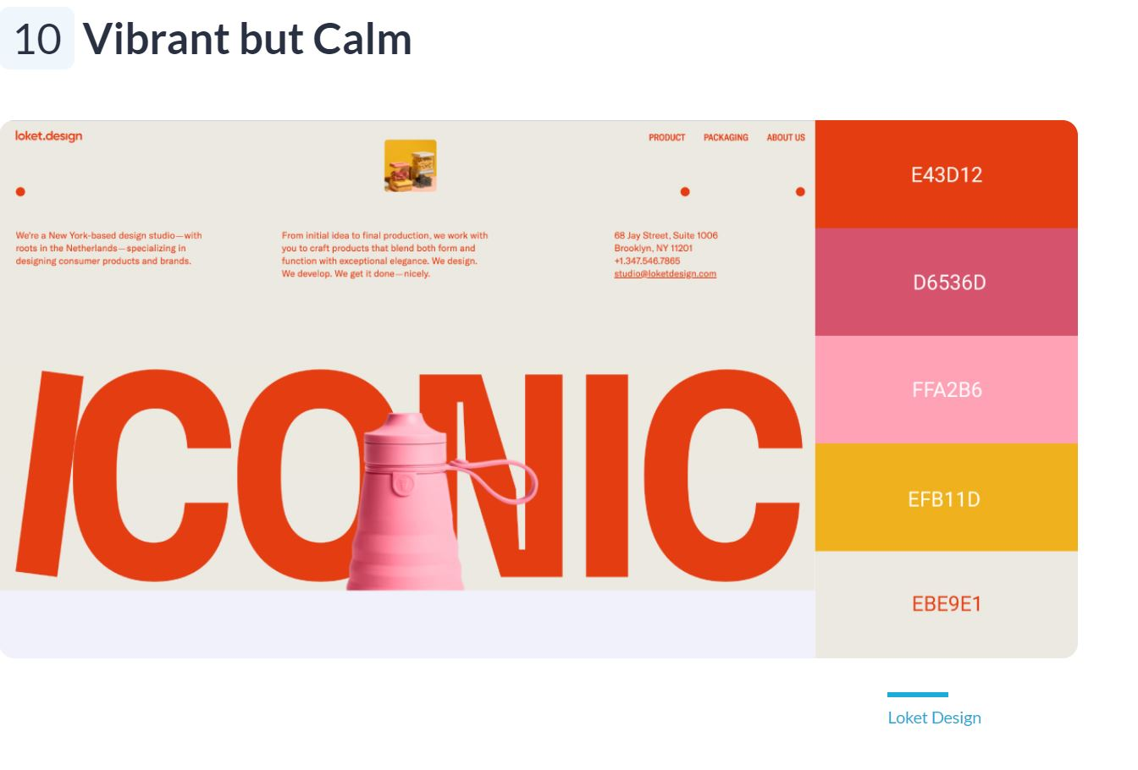

# Header

I wanted to add a creative header for my webpage that would be liked by my target audience while keeping in the theme of website.

I came up with the idea of adding pictures of small snakes and old mobile phones in the background of the main text while trying to keep with the colour scheme (as shown previously).

The followed the colour scheme and went for a background colour of #EBE9E1.

I also needed a snake and a mobile phone image so I went with these two:

Snake. [(Dias, no date)](https://sciwheel.com/work/citation?ids=16581974&pre=&suf=&sa=0&dbf=0)



Phone. [(PixaBay, 2014)](https://sciwheel.com/work/citation?ids=16581982&pre=&suf=&sa=0&dbf=0)

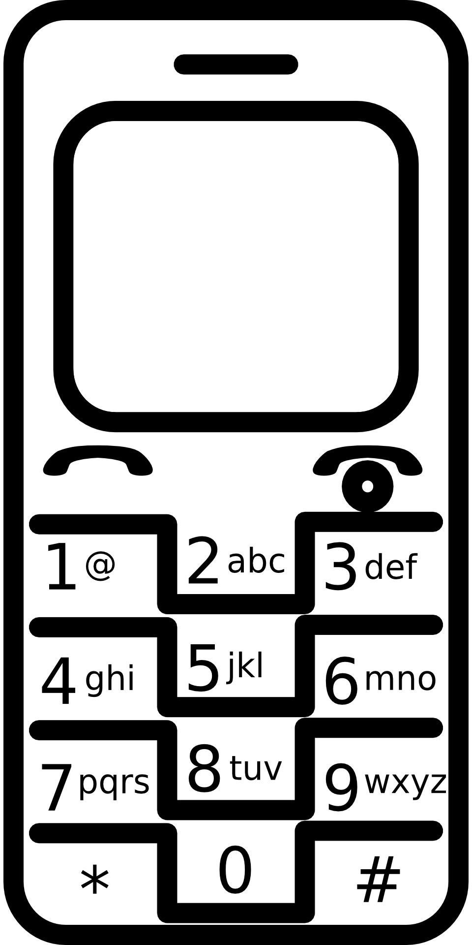

I used all these images and colours as long with deciding to go with the font Poppins, I made this header.



# History and Today

I wanted to talk about how the history of how mobile games came about as well as where they are today.

I got the history and current status of mobile games from two sources. Wikipedia [(*Mobile Game*, no date)](https://sciwheel.com/work/citation?ids=16582000&pre=&suf=&sa=0&dbf=0) and ChatGPT.

With both sources I was able to write a brief history on how mobile games started as well as explain how far they have come and how they are used today.

I also wanted to be creative on this section, so I decided to make text speech bubbles explaining them.

## Text and Colour

I thought the best template I could use for this section was Apple’s own text colour and font. Apple's design is simple and clear, which makes it a good choice for this project. I found the specific colours that Apple uses for their message bubbles, like blue for iMessages and green for SMS messages [(mattpeculiar, no date)](https://sciwheel.com/work/citation?ids=16588704&pre=&suf=&sa=0&dbf=0). Getting these colours right was important to make it look authentic.

I also needed to find the exact font that Apple uses in their text messages. Apple uses the San Francisco font, which is modern and easy to read [(FullStack, 2015)](https://sciwheel.com/work/citation?ids=16588712&pre=&suf=&sa=0&dbf=0). Using this font would help make the messages look like real Apple messages.

## Speech Bubble

Besides colours and fonts, I wanted the messages to look like text messages, so I needed to create speech bubbles. I found a helpful tutorial on YouTube that showed me how to design speech bubbles. The tutorial explained how to make the bubble shapes, shadows, and borders look realistic. [(ThinhPham, 2022)](https://sciwheel.com/work/citation?ids=16588700&pre=&suf=&sa=0&dbf=0)

In the end, using Apple’s text colour, font, and adding speech bubbles made the design look like Apple’s messaging system. This not only made it look good but also made it easy for users to recognize and use.

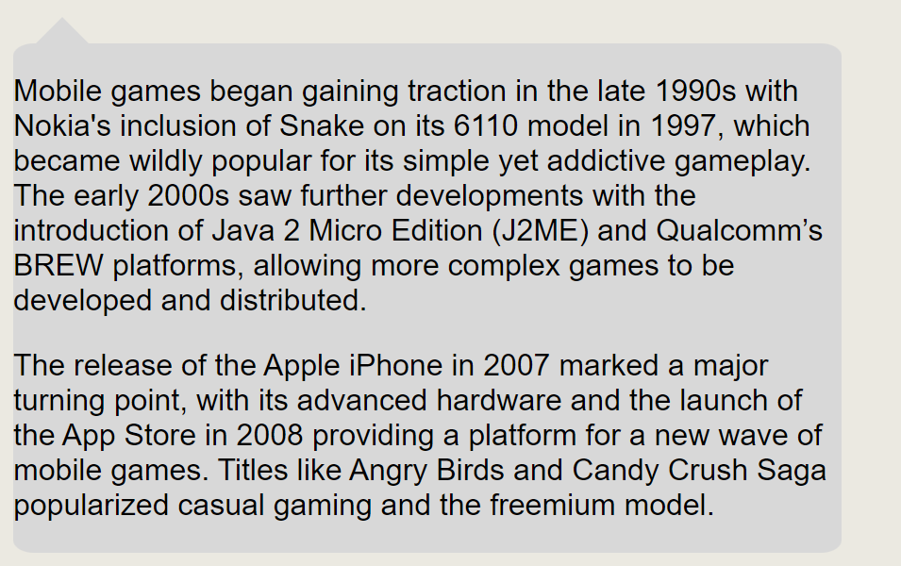

# First Five Games

As this website was about explaining the history of mobile games, I thought it would be good to show the first five mobile games to come out. They were all made by Nokia and found the dates they came out on Wikipedia. [(*Mobile Game*, no date)](https://sciwheel.com/work/citation?ids=16582000&pre=&suf=&sa=0&dbf=0)

I then wanted to try and find the original pictures of the first five games to add to my website. I ended up downloading them all make them all 48X48 pixel.

Memory[(*Memory png*, no date)](https://sciwheel.com/work/citation?ids=16588737&pre=&suf=&sa=0&dbf=0)



Snake [(*Snake png*, no date)](https://sciwheel.com/work/citation?ids=16588738&pre=&suf=&sa=0&dbf=0)



Snakes[(*Snakes png*, no date)](https://sciwheel.com/work/citation?ids=16588742&pre=&suf=&sa=0&dbf=0)



Tetris [(*Tetris png*, no date)](https://sciwheel.com/work/citation?ids=16588740&pre=&suf=&sa=0&dbf=0)



Logic [(*Logic png*, no date)](https://sciwheel.com/work/citation?ids=16588736&pre=&suf=&sa=0&dbf=0)



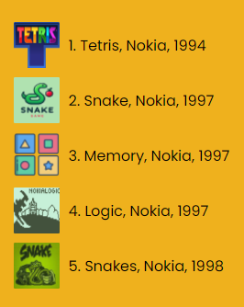

# Snake Game

When I was looking to make a game for my website I thought it had to be related to what I have already mentioned as well as being well known and easy to play.

After looking at the first five mobile games I mentioned above I decided on making Snake.

There were several great tutorials for the game snake, some more complex than others. I wanted to find a very simple version to with for my website but something I feel would not look too outdated.

I followed a tutorial on YouTube called “A game of Snake written in JavaScript 🐍”[(BroCode, 2022)](https://sciwheel.com/work/citation?ids=16588809&pre=&suf=&sa=0&dbf=0). This was on the “BroCode” channel, and it was very easy to understand and follow. I made sure to add notes to my program to understand what every bit of code did.

While following this tutorial I made some changes to the original design with removing the pop-up message and instead creating a game over screen on the game itself.

With the original design I wanted a feature to allow the user to increase the speed of the snake by adjusting a scale. I later found out while writing the code for snake that there was a bug that you if you click the reset button more than once it would increase the speed of the snake by an extra 100% every time you click it before the snake spawns in. I found a way to fix this issue however I decided to leave it in and instead I left a note at the bottom saying “ 🐍 Want a challenge? Try clicking reset/space twice! 🐍”.

I did try and add an element of this with a scale by having the number you add to the scale the amount of time the reset button would be pressed e.g. If I choose 3 on the scale the code will press the reset button three times and the snake would go triple the normal speed. Sadly, this was not possible with the time limit, but I was very happy how it came out.

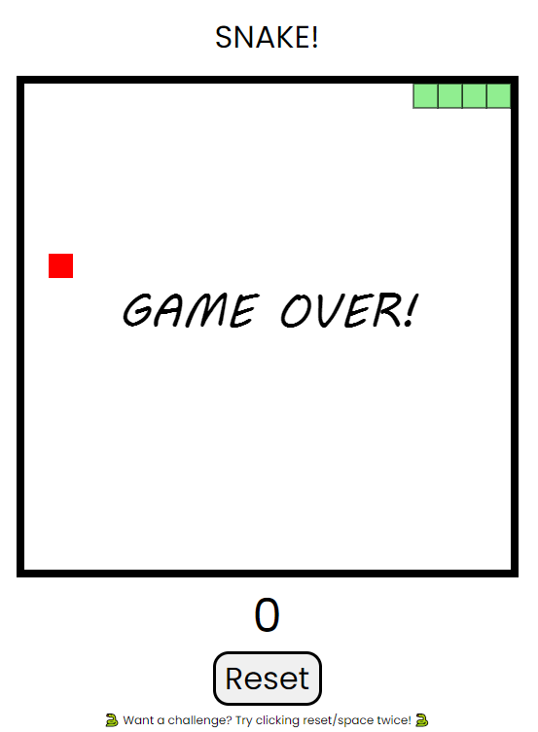

[BroCode (2022) *A game of Snake written in JavaScript 🐍*, *YouTube*. Available at: https://www.youtube.com/watch?v=Je0B3nHhKmM (Accessed: June 23, 2024).](https://sciwheel.com/work/bibliography/16588809)

[Chibana, N. (no date) *50 Gorgeous Color Schemes From Stunning Websites*, *50 Gorgeous Color Schemes*. Available at: https://visme.co/blog/website-color-schemes/ (Accessed: April 15, 2024).](https://sciwheel.com/work/bibliography/16581920)

[Dias, T. (no date) *Snake Photo PNG*.](https://sciwheel.com/work/bibliography/16581974)

[FullStack (2015) *Apple’s San Francisco font on a site*, *Apple’s San Francisco font on a site*. Available at: https://stackoverflow.com/questions/32660748/how-to-use-apples-san-francisco-font-on-a-webpage (Accessed: June 23, 2024).](https://sciwheel.com/work/bibliography/16588712)

[*Logic png* (no date) *img.itch.zone*. Available at: https://img.itch.zone/aW1nLzgxNTMyOTIucG5n/315x250%23c/rH0Xnm.png (Accessed: June 23, 2024).](https://sciwheel.com/work/bibliography/16588736)

[mattpeculiar (no date) *Text Messages Color Palette*, *Color-Hex*. Available at: https://www.color-hex.com/color-palette/13071 (Accessed: June 23, 2024).](https://sciwheel.com/work/bibliography/16588704)

[*Memory png* (no date) *flaticon.com*. Available at: https://cdn-icons-png.flaticon.com/512/6168/6168860.png (Accessed: June 23, 2024).](https://sciwheel.com/work/bibliography/16588737)

[*Mobile Game* (no date) *Mobile Game*. Available at: https://en.wikipedia.org/wiki/Mobile_game (Accessed: June 21, 2024).](https://sciwheel.com/work/bibliography/16582000)

[PixaBay (2014) *Phone Photo PNG*.](https://sciwheel.com/work/bibliography/16581982)

[*Snakes png* (no date) *raisoni.net*. Available at: https://ghrcem-ghremf./?s=jeu-d-ambiance-gigamic-snakes-jeux-d-ambiance-achat-8-oo-gEdYAzIA (Accessed: June 23, 2024).](https://sciwheel.com/work/bibliography/16588742)

[*Snake png* (no date) *googleusercontent.com*. Available at: https://play-lh.googleusercontent.com/S9ZmNx5LYCj7h2IJZb0QqkXAGki6JRaMQ25ycKfrngDkNBA6jk7rM87YcAH1prV_OA (Accessed: June 23, 2024).](https://sciwheel.com/work/bibliography/16588738)

[*Tetris png* (no date) *Wikimedia*. Available at: https://upload.wikimedia.org/wikipedia/commons/4/46/Tetris_logo.png (Accessed: June 23, 2024).](https://sciwheel.com/work/bibliography/16588740)

[ThinhPham (2022) *Speech Bubble*, *YouTube*. Available at: https://www.youtube.com/watch?v=SC0P35HnbBY (Accessed: June 23, 2024).](https://sciwheel.com/work/bibliography/16588700)